HTML5 Animation

# Documentation

* Web Animations API: <https://developer.mozilla.org/en-US/docs/Web/API/Web_Animations_API>

# Demos

* <https://webdesigner-webdeveloper.com/weblog/exploring-web-animations/>

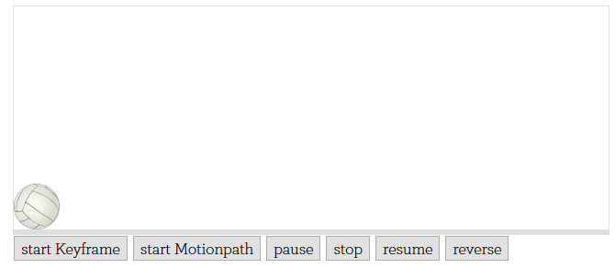

* <https://web-animations.github.io/web-animations-demos/#galaxy/>